**First Method**

**Step 1:**  
In Eclipse, on top menu bar, Under Help Menu, Click on "Eclipse Marketplace" in help window.

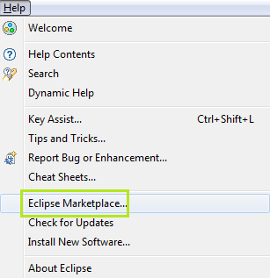

**Step 2:**  
Enter “TestNG” in search bar of the window opened and click enter to search.

Click Install to install it

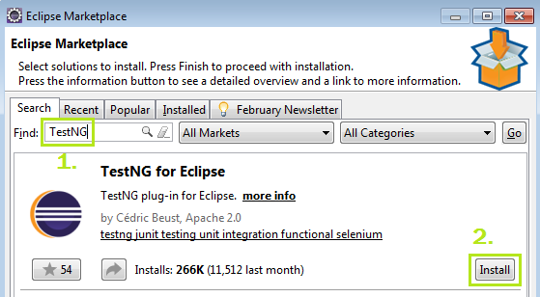

**Step 3:**  
Click "Confirm" button and accept the license and click “Finish” to complete the installation.

**Step 4:**  
Restart Eclipse and verify the plugin is installed successfully

**Second Method:**

**Step 1:**  
In Eclipse, on top menu bar, Under Help Menu, Click on "Install New Software" in help window.

**Step 2:**

“Install” dialog will open. In the dialog, click on “Add” button.

**Step 3:**

Enter below values in the below dialog:

Name: TestNG

Location: <https://testng.org/testng-eclipse-update-site>

Click on Add.

**Step 4:**

Select TestNG and click on Next button.Accept the license and click “Finish” to complete the installation.

**Step 5:**  
Restart Eclipse and verify the plugin is installed successfully

**Third Method:**

**Step 1:**

Download the zip file using below path:

<https://testng.org/testng-eclipse-update-site/zipped/7.4.0.202106051955/org.testng.eclipse.updatesite.zip>

Save the file at some secure place.

**Step 2:**

In Eclipse, on top menu bar, Under Help Menu, Click on "Install New Software" in help window.

**Step 2:**

“Install” dialog will open. In the dialog, click on “Add” button.

**Step 3:**

Click on the ‘Archive’ button, select the zip file (saved in step 1) and click on Add button.

**Step 4:**

Select TestNG and click on Next button.Accept the license and click “Finish” to complete the installation.

**Step 5:**  
Restart Eclipse and verify the plugin is installed successfully.